SERVLET + JSP + MySQL

SINH VIÊN THAM KHẢO 3 VÍ DỤ SAU ĐÂY

====== ==============================================

<https://thaihoanghai.wordpress.com/2013/04/22/servlet-jsp-example-mysql/>

<https://giai-ma.blogspot.com/2016/08/add-update-delete-voi-mysql-jsp-servlet.html>

<http://www.javaknowledge.info/search-from-database-using-servlet-and-jsp/>

**Tham khảo thêm**

[1] <https://www.ntu.edu.sg/home/ehchua/programming/java/JavaServlets.html>

# [2] Spring MVC Example for User Registration and Login <https://dzone.com/articles/spring-mvc-example-for-user-registration-and-login-1>

**VÍ DỤ 1**

Ok sau bài này mình hướng dẫn các bạn bài tập kết nối đến database mysql . và 1 trang quản lì sản phẩm cơ bản như sau :

Chúng ta có database như hình vẻ sau :

[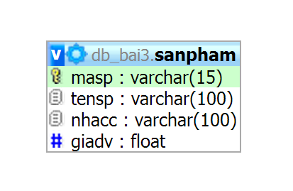](https://thaihoanghai.files.wordpress.com/2013/04/d150.png)

Chương trình chúng ta như sau : trang index sẻ hiển thị như sau :

[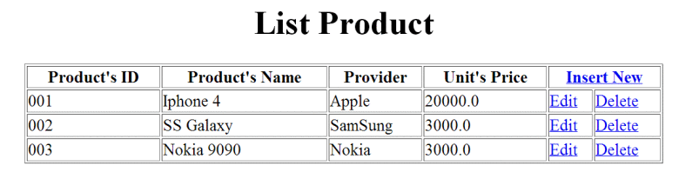](https://thaihoanghai.files.wordpress.com/2013/04/d151.png)

Khi ta nhấn vào Link Insert New chúng ta sẻ hiển thị trang thêm sản phấm : insert.jsp

[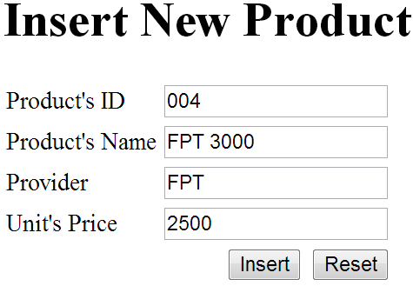](https://thaihoanghai.files.wordpress.com/2013/04/d152.png)

Khi ta nhấn insert button sẻ hiển thị trở lại trang index.jsp với sản phẩm vửa được nhập :

[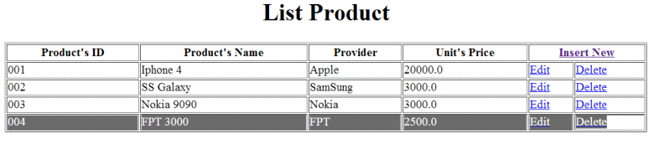](https://thaihoanghai.files.wordpress.com/2013/04/d153.png)

Khi ta nhấn Edit sẻ hiển thị trang edit.jsp củng với data hiển thi sẳn trong table của chúng ta :

[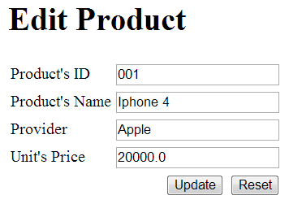](https://thaihoanghai.files.wordpress.com/2013/04/d154.png)

Tương tự khi update xong chúng ta củng hiển thị lại List các sản phẩm . và sản phẩm được cập nhật. Tương ứng khi ta nhận delete thì sản phẩm sẻ bị xóa đi, và cập nhật lại table của chúng ta. OK bài này như sau :

Để kết nối mysql chúng ta cần driver : mysql_connector-java-5.x.x-bin.jar. các bạn có thể search ở google. và down load về bỏ vào thư mục lib bên dưới thư mục Webcontent/Web-inf/lib.

Hình ảnh toàn bộ Project của mình như sau :

[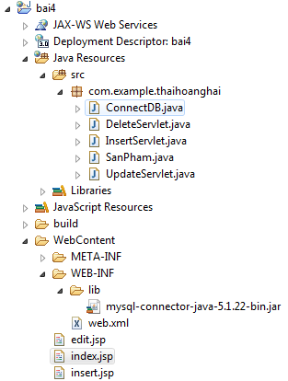](https://thaihoanghai.files.wordpress.com/2013/04/d155.png)

Code: index.jsp

|  |  |
| --- | --- |
| 1  2  3  4  5  6  7  8  9  10  11  12  13  14  15  16  17  18  19  20  21  22  23  24  25  26  27  28  29  30  31  32  33  34  35  36  37  38  39  40  41 | <%@page import="com.example.thaihoanghai.ConnectDB"%>  <%@page import="com.example.thaihoanghai.SanPham"%>  <%@page import="java.util.ArrayList"%>  <%@ page language="java" contentType="text/html; charset=ISO-8859-1"   pageEncoding="ISO-8859-1"%>  <!DOCTYPE html PUBLIC "-//W3C//DTD HTML 4.01 Transitional//EN" "<http://www.w3.org/TR/html4/loose.dtd>">  <html>  <head>  <meta http-equiv="Content-Type" content="text/html; charset=ISO-8859-1">  <title>Product Information</title>  </head>  <body>   <% ArrayList<SanPham> lst = new ConnectDB().getAllProducts(); %>   <h1 align="center">List Product</h1>   <table border="1" width="80%" align="center">   <tr>   <th>Product's ID</th>   <th>Product's Name</th>   <th>Provider</th>   <th>Unit's Price</th>   <th colspan="2"><a href="insert.jsp">Insert New</a></th>   </tr>   <%   for(SanPham sp : lst){   String editURL = "edit.jsp?masp="+sp.getMasp();   String deleteURL = "DeleteServlet?masp="+sp.getMasp();   %>   <tr>   <td><%=sp.getMasp() %></td>   <td><%=sp.getTensp() %></td>   <td><%=sp.getNhacc() %></td>   <td><%=sp.getGiadv() %></td>   <td><a href="<%=editURL%>">Edit</a></td>   <td><a href="<%=deleteURL%>">Delete</a></td>   </tr>   <%   }   %>   </table>  </body>  </html> |

page insert.jsp

|  |  |
| --- | --- |
| 1  2  3  4  5  6  7  8  9  10  11  12  13  14  15  16  17  18  19  20  21  22  23  24  25  26  27  28  29  30  31  32  33  34  35  36  37  38  39 | <%@ page language="java" contentType="text/html; charset=ISO-8859-1"   pageEncoding="ISO-8859-1"%>  <!DOCTYPE html PUBLIC "-//W3C//DTD HTML 4.01 Transitional//EN" "<http://www.w3.org/TR/html4/loose.dtd>">  <html>  <head>  <meta http-equiv="Content-Type" content="text/html; charset=ISO-8859-1">  <title>Insert Product</title>  </head>  <body>  <form action="InsertServlet">   <h1>Insert New Product</h1>   <table>   <tr>   <td>Product's ID</td>   <td><input type="text" name="masp"></td>   </tr>   <tr>   <td>Product's Name</td>   <td><input type="text" name="tensp"></td>   </tr>   <tr>   <td>Provider</td>   <td><input type="text" name="nhacc"></td>   </tr>   <tr>   <td>Unit's Price</td>   <td><input type="text" name="giadv"></td>   </tr>   <tr>     <td colspan="2" align="right">   <button type="submit" name="insert">Insert</button>   <button type="reset" name="reset">Reset</button>   </td>   </tr>   </table>  </form>  </body>  </html> |

page edit.jsp

|  |  |
| --- | --- |
| 1  2  3  4  5  6  7  8  9  10  11  12  13  14  15  16  17  18  19  20  21  22  23  24  25  26  27  28  29  30  31  32  33  34  35  36  37  38  39  40  41  42 | <%@page import="com.example.thaihoanghai.ConnectDB"%>  <%@page import="com.example.thaihoanghai.SanPham"%>  <%@ page language="java" contentType="text/html; charset=ISO-8859-1"   pageEncoding="ISO-8859-1"%>  <!DOCTYPE html PUBLIC "-//W3C//DTD HTML 4.01 Transitional//EN" "<http://www.w3.org/TR/html4/loose.dtd>">  <html>  <head>  <meta http-equiv="Content-Type" content="text/html; charset=ISO-8859-1">  <title>Edit Product</title>  </head>  <body>  <% SanPham sp = new ConnectDB().getProductByID(request.getParameter("masp")); %>  <form action="UpdateServlet">   <h1>Edit Product</h1>   <table>   <tr>   <td>Product's ID</td>   <td><input type="text" name="masp" value="<%=sp.getMasp()%>" readonly="readonly"></td>   </tr>   <tr>   <td>Product's Name</td>   <td><input type="text" name="tensp" value="<%=sp.getTensp()%>"></td>   </tr>   <tr>   <td>Provider</td>   <td><input type="text" name="nhacc" value="<%=sp.getNhacc()%>" /></td>   </tr>   <tr>   <td>Unit's Price</td>   <td><input type="text" name="giadv" value="<%=sp.getGiadv()%>" /></td>   </tr>   <tr>     <td colspan="2" align="right">   <button type="submit" name="update">Update</button>   <button type="reset" name="reset">Reset</button>   </td>   </tr>   </table>  </form>  </body>  </html> |

Class ConnectDB.java

|  |  |
| --- | --- |
| 1  2  3  4  5  6  7  8  9  10  11  12  13  14  15  16  17  18  19  20  21  22  23  24  25  26  27  28  29  30  31  32  33  34  35  36  37  38  39  40  41  42  43  44  45  46  47  48  49  50  51  52  53  54  55  56  57  58  59  60  61  62  63  64  65  66  67  68  69  70  71  72  73  74  75  76  77  78  79  80  81  82  83  84  85  86  87  88  89  90  91  92  93  94  95  96  97  98  99  100  101  102  103  104  105  106  107  108  109  110  111  112  113  114  115  116  117  118  119  120  121  122  123  124  125  126  127  128  129  130  131  132  133  134  135  136  137  138  139  140  141  142  143  144  145  146  147  148  149  150  151  152  153  154  155  156  157  158  159  160  161  162  163  164  165  166  167  168  169 | package com.example.thaihoanghai;  /*   * To change this template, choose Tools | Templates   * and open the template in the editor.   */  import java.sql.Connection;  import java.sql.DriverManager;  import java.sql.PreparedStatement;  import java.sql.ResultSet;  import java.sql.SQLException;  import java.sql.Statement;  import java.util.ArrayList;  /**   * This class used : open/close Connect to DB and create Query   * @author kobe   */  public class ConnectDB {    Connection connect = null;   Statement stmt = null;   ResultSet rs = null;    /**   * Check Driver connect to MySQL   */   protected void hasDriver() throws Exception{   try {   Class.forName("com.mysql.jdbc.Driver");   } catch (ClassNotFoundException ex) {   throw new Exception ("Invalid Driver!!Please check this drver....");   }   }    /**   * Function used to get the connection to the Database   * Step 1 - I check my connection or not!!   * Step 2 - If not, it will be null and initialization.   * Step 3 - Then it return   * @return Connection   */   protected Connection openConnect() throws Exception{   if(connect == null){   hasDriver();   String url = "jdbc:<mysql://localhost/db_bai3>";   // url_sql = "....";   try {   this.connect = DriverManager.getConnection(url,"root","");   } catch (SQLException e) {   throw new Exception(e.getMessage() + "Connect failed to database .... ");   }   }   return connect;   }   /**   * Make a Statement to execute the SQL statement   * @return Statement   */   protected Statement getStatement() throws SQLException, Exception{   if(stmt == null){   stmt = openConnect().createStatement();   }   return stmt;   }   /**   * Used to execute the Select statement   * @param strSQL Query VD: Select * from Employee   * @return ResultSet   */   public ArrayList<SanPham> getAllProducts() throws Exception{   ArrayList<SanPham> lst = new ArrayList<SanPham>();   String strSQL = "select * from SanPham";   try {   rs = getStatement().executeQuery(strSQL);   while(rs.next()){   String ms = rs.getString("masp");   String ten = rs.getString("tensp");   String ncc = rs.getString("nhacc");   double gia = Double.parseDouble(rs.getString("giadv"));   SanPham sp = new SanPham(ms, ten, ncc, gia);   lst.add(sp);   }   } catch (Exception e) {   throw new Exception(e.getMessage() +" Error at : " + strSQL);   }   closeConnet();   return lst;   }     public boolean insertNew(SanPham sp) throws Exception{   String sql = "insert into SanPham values(?,?,?,?)";   PreparedStatement pst = openConnect().prepareStatement(sql);   pst.setString(1, sp.getMasp());   pst.setString(2, sp.getTensp());   pst.setString(3, sp.getNhacc());   pst.setDouble(4, sp.getGiadv());     return pst.executeUpdate() > 0;     }     public boolean deleteProduct(String masp) throws Exception{   String sql = "delete from SanPham where masp=?";   PreparedStatement pst = openConnect().prepareStatement(sql);   pst.setString(1, masp);   return pst.executeUpdate() > 0;   }     /**   * Used to execute the Insert, Update, Delete statement   * @param strSQL Query VD: Insert into TableName values ('??','??')   * @return The number of lines affected by the command   */   public int executeUpdate(String strSQL) throws Exception{   int result = 0;   try {   result = getStatement().executeUpdate(strSQL);   } catch (Exception ex) {   throw new Exception(ex.getMessage() + " Error at: " + strSQL);   }finally{   this.closeConnet();   }   return result;   }     public SanPham getProductByID(String masp)throws Exception{   String sql = "select * from SanPham where masp=?";   PreparedStatement pst = openConnect().prepareStatement(sql);   pst.setString(1, masp);   ResultSet rs = pst.executeQuery();   SanPham sp = null;   if(rs.next()){   String ms = rs.getString("masp");   String ten = rs.getString("tensp");   String ncc = rs.getString("nhacc");   double gia = Double.parseDouble(rs.getString("giadv"));   sp = new SanPham(ms, ten, ncc, gia);   }   return sp;   }     public boolean UpdateProduct(String masp,SanPham newsp) throws Exception{   String sql = "update SanPham set tensp=?, nhacc=?, giadv=? where masp=?";   PreparedStatement pst = openConnect().prepareStatement(sql);   pst.setString(1, newsp.getTensp());   pst.setString(2, newsp.getNhacc());   pst.setDouble(3, newsp.getGiadv());   pst.setString(4, newsp.getMasp());   return pst.executeUpdate()>0;   }   /**   * A method to close the connection.   * @throws SQLException   */   public void closeConnet() throws SQLException{   if(rs != null && !rs.isClosed())   rs.close();   if(stmt != null)   stmt.close();   if(connect != null)   connect.close();   }     public static void main(String[] args) throws Exception {   new ConnectDB().UpdateProduct("sp01", new SanPham("sp01", "AAAA", "BBBB", 1000));   System.out.println(new ConnectDB().getProductByID("sp01").getTensp());     }    } |

Class Sanpham.java

|  |  |
| --- | --- |
| 1  2  3  4  5  6  7  8  9  10  11  12  13  14  15  16  17  18  19  20  21  22  23  24  25  26  27  28  29  30  31  32  33  34  35  36  37  38  39  40  41  42  43  44  45  46  47  48  49  50  51  52  53  54  55  56  57  58  59  60  61  62  63  64  65  66  67 | package com.example.thaihoanghai;    public class SanPham {   private String masp;   private String tensp;   private String nhacc;   private double giadv;     public SanPham(String masp, String tensp, String nhacc, double giadv) {   this.masp = masp;   this.tensp = tensp;   this.nhacc = nhacc;   this.giadv = giadv;   }    public SanPham() {   }     public String getMasp() {   return masp;   }   public void setMasp(String masp) {   this.masp = masp;   }   public String getTensp() {   return tensp;   }   public void setTensp(String tensp) {   this.tensp = tensp;   }   public String getNhacc() {   return nhacc;   }   public void setNhacc(String nhacc) {   this.nhacc = nhacc;   }   public double getGiadv() {   return giadv;   }   public void setGiadv(double giadv) {   this.giadv = giadv;   }   @Override   public int hashCode() {   final int prime = 31;   int result = 1;   result = prime * result + ((masp == null) ? 0 : masp.hashCode());   return result;   }   @Override   public boolean equals(Object obj) {   if (this == obj)   return true;   if (obj == null)   return false;   if (getClass() != obj.getClass())   return false;   SanPham other = (SanPham) obj;   if (masp == null) {   if (other.masp != null)   return false;   } else if (!masp.equals(other.masp))   return false;   return true;   }    } |

Trang servlet : InsertServlet.java tùy chỉnh trong doget như sau :

|  |  |
| --- | --- |
| 1  2  3  4  5  6  7  8  9  10  11  12  13  14  15  16  17  18 | protected void doGet(HttpServletRequest request, HttpServletResponse response) throws ServletException, IOException {   String masp = request.getParameter("masp");   String tensp = request.getParameter("tensp");   String nhacc = request.getParameter("nhacc");   double giadv = Double.parseDouble(request.getParameter("giadv"));     SanPham sp = new SanPham(masp, tensp, nhacc, giadv);   ConnectDB db = new ConnectDB();   try {   if(db.insertNew(sp))   response.sendRedirect("index.jsp");   else   response.sendRedirect("error.jsp");   } catch (Exception e) {   // TODO Auto-generated catch block   e.printStackTrace();   }   } |

Trang Servlet UpdateServlet.java

|  |  |
| --- | --- |
| 1  2  3  4  5  6  7  8  9  10  11  12  13  14  15  16  17  18  19 | protected void doGet(HttpServletRequest request, HttpServletResponse response) throws ServletException, IOException {   String masp = request.getParameter("masp");   String tensp = request.getParameter("tensp");   String nhacc = request.getParameter("nhacc");   double giadv = Double.parseDouble(request.getParameter("giadv"));     SanPham sp = new SanPham(masp, tensp, nhacc, giadv);   ConnectDB db = new ConnectDB();   try {   if(db.UpdateProduct(masp, sp))   response.sendRedirect("index.jsp");   else   response.sendRedirect("error.jsp");   } catch (Exception e) {   // TODO Auto-generated catch block   e.printStackTrace();   }     } |

Page servlet DeleteServlet.java

|  |  |
| --- | --- |
| 1  2  3  4  5  6  7  8  9  10  11  12  13  14 | protected void doGet(HttpServletRequest request, HttpServletResponse response) throws ServletException, IOException {   String masp = request.getParameter("masp");   ConnectDB connect = new ConnectDB();   try {   if(connect.deleteProduct(masp))   response.sendRedirect("index.jsp");   else   response.sendRedirect("error.jsp");   } catch (Exception e) {   // TODO Auto-generated catch block   e.printStackTrace();   }    } |

Ok chúc các bạn thành công.

**VÍ DỤ 2**

**Database mysql**

[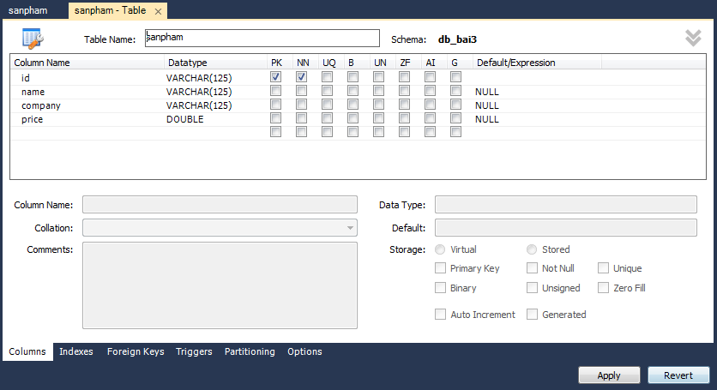](https://1.bp.blogspot.com/-iowdgUimA_Y/V7nLL683FqI/AAAAAAAABrI/0kLdzd4khzQsE1ArM4mImxMzmp-NYVWIgCLcB/s1600/2016-08-21_223915.png)

**http://localhost:8084/baiTest1/index.jsp**

**[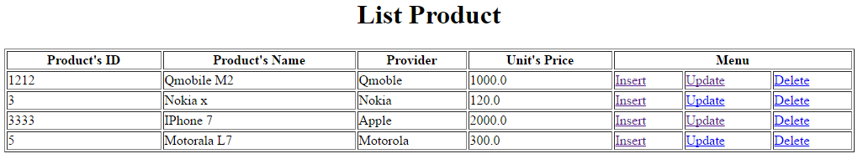](https://4.bp.blogspot.com/-pkzDfCQe_rk/V7nOh6N9FbI/AAAAAAAABrY/7E_O--KFbIgujaW1pou8kETbk0h2Omv9gCLcB/s1600/2016-08-21_225334.png)**

**http://localhost:8084/baiTest1/insert.jsp**

**[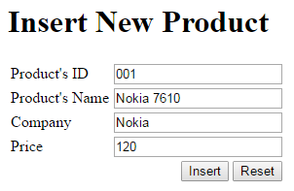](https://3.bp.blogspot.com/-V85AodlU6Pg/V7nPBpjTX9I/AAAAAAAABrk/yNnfjVRu020IQXpk4tSP5f3ano3NmnCpQCLcB/s1600/2016-08-21_225531.png)**

Khi ta nhấn insert button sẻ hiển thị trở lại trang index.jsp với sản phẩm vửa được nhập :

[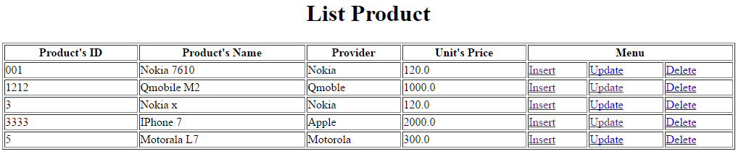](https://1.bp.blogspot.com/-aoLHXR24DLY/V7nPPX0ntSI/AAAAAAAABro/ehU5Bq32XsAc_PX7ONcT_MEEf41xN9rmwCLcB/s1600/2016-08-21_225632.png)

**http://localhost:8084/baiTest1/update.jsp?id=001**

**[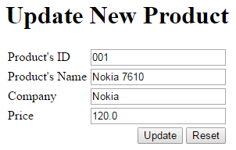](https://2.bp.blogspot.com/-MDIMTkog3vE/V7nP1MnnJyI/AAAAAAAABrw/QcDAZzBcxOEdQEhcEB7C_mfnHioAvsAgQCLcB/s1600/2016-08-21_225826.png)**

Tương tự khi update xong chúng ta củng hiển thị lại List các sản phẩm . và sản phẩm được cập nhật. Tương ứng khi ta nhận delete thì sản phẩm sẻ bị xóa đi, và cập nhật lại table của chúng ta. OK bài này như sau :

Để kết nối mysql chúng ta cần driver : **mysql_connector-java-5.x.x-bin.jar**. hoặc nếu dùng mysql workbench thì **C:\Program Files\MySQL\Connector.J 5.1** hoặc các bạn có thể search ở google. và down load về bỏ vào thư mục lib bên dưới thư mục **Webcontent/Web-inf/lib**.

[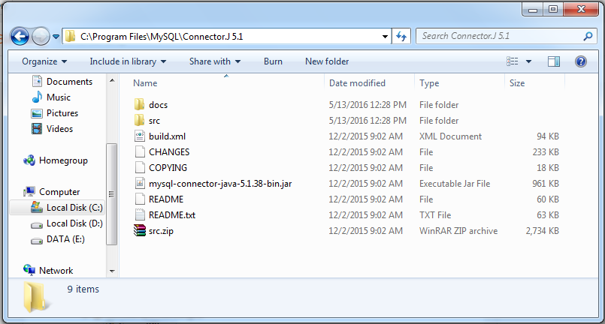](https://1.bp.blogspot.com/-nF7gTzZEoDs/V7fVuX_IY9I/AAAAAAAABps/savZC1WqwZYB3ffxPbNESyhEfzdeK4RkwCLcB/s1600/2016-08-20_105912.png)

Hình ảnh toàn bộ Project của NetBeans như sau :

[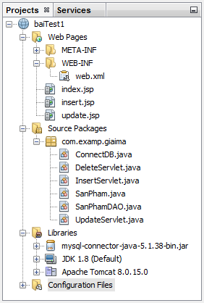](https://4.bp.blogspot.com/-9nvf89aB1Bc/V7nJbr5ElJI/AAAAAAAABq8/hh-_okfyGkMKVpNgwf4bNui4IcycxTS3wCLcB/s1600/2016-08-21_223137.png)

**Page: index.jsp**

**Java 2016**

<%--

Document : index

Created on : Aug 20, 2016, 10:06:12 AM

Author : Lonely

--%>

<%@page import="com.examp.giaima.SanPhamDAO"%>

<%@page import="com.examp.giaima.SanPham"%>

<%@page import="java.util.ArrayList"%>

<%@ page language="java" contentType="text/html; charset=ISO-8859-1"

pageEncoding="ISO-8859-1"%>

<!DOCTYPE html PUBLIC "-//W3C//DTD HTML 4.01 Transitional//EN" "http://www.w3.org/TR/html4/loose.dtd">

<html>

<head>

<meta http-equiv="Content-Type" content="text/html; charset=ISO-8859-1">

<title>Product Information</title>

</head>

<body>

<% ArrayList<SanPham> lst = new SanPhamDAO().getAllProducts(); %>

<h1 align="center">List Product</h1>

<table border="1" width="80%" align="center">

<tr>

<th>Product's ID</th>

<th>Product's Name</th>

<th>Provider</th>

<th>Unit's Price</th>

<th colspan="3">Menu</th>

</tr>

<%

for (SanPham sp : lst) {

String editURL = "update.jsp?id=" + sp.getID();

String deleteURL = "DeleteServlet?id=" + sp.getID();

%>

<tr>

<td><%= sp.getID() %></td>

<td><%=sp.getName()%></td>

<td><%=sp.getCompany()%></td>

<td><%=sp.getPrice()%></td>

<td><a href="insert.jsp">Insert</a></td>

<td><a href="<%=editURL%>">Update</a></td>

<td><a href="<%=deleteURL%>">Delete</a></td>

</tr>

<%

}

%>

</table>

</body>

</html>

**Page: insert.jsp**

**Java 2016**

<%--

Document : insert

Created on : Aug 21, 2016, 12:57:47 PM

Author : Lonely

--%>

<%@page contentType="text/html" pageEncoding="UTF-8"%>

<!DOCTYPE html>

<html>

<head>

<meta http-equiv="Content-Type" content="text/html; charset=UTF-8">

<title>Insert Product</title>

</head>

<body>

<form action="InsertServlet" method="POST">

<h1>Insert New Product</h1>

<table>

<tr>

<td>Product's ID</td>

<td><input type="text" name="id"></td>

</tr>

<tr>

<td>Product's Name</td>

<td><input type="text" name="name"></td>

</tr>

<tr>

<td>Company</td>

<td><input type="text" name="company"></td>

</tr>

<tr>

<td>Price</td>

<td><input type="text" name="price"></td>

</tr>

<tr>

<td colspan="2" align="right">

<button type="submit" name="insert">Insert</button>

<button type="reset" name="reset">Reset</button>

</td>

</tr>

</form>

</body>

</html>

**Page: update.jsp**

**Java 2016**

<%--

Document : update

Created on : Aug 21, 2016, 8:22:59 PM

Author : Lonely

--%>

<%@page import="com.examp.giaima.SanPhamDAO"%>

<%@page import="com.examp.giaima.SanPham"%>

<%@page import="java.util.ArrayList"%>

<%@page contentType="text/html" pageEncoding="UTF-8"%>

<!DOCTYPE html>

<html>

<head>

<meta http-equiv="Content-Type" content="text/html; charset=UTF-8">

<title>Update JSP</title>

</head>

<body>

<%

String id = request.getParameter("id");

SanPham sp = new SanPhamDAO().getSanPhamID(id);

%>

<form action="UpdateServlet" method="POST">

<h1>Update New Product</h1>

<table>

<tr>

<td>Product's ID</td>

<td><input type="text" name="id" value="<%=sp.getID()%>"></td>

</tr>

<tr>

<td>Product's Name</td>

<td><input type="text" name="name" value="<%=sp.getName()%>"></td>

</tr>

<tr>

<td>Company</td>

<td><input type="text" name="company" value="<%=sp.getCompany()%>"></td>

</tr>

<tr>

<td>Price</td>

<td><input type="text" name="price" value="<%=sp.getPrice()%>"></td>

</tr>

<tr>

<td colspan="2" align="right">

<button type="submit" name="Update">Update</button>

<button type="reset" name="reset">Reset</button>

</td>

</tr>

</form>

</body>

</html>

**Class ConnectDB.java**

**Java 2016**

package com.examp.giaima;

import java.sql.Connection;

import java.sql.DriverManager;

import java.sql.ResultSet;

import java.sql.SQLException;

import java.sql.Statement;

/**

*

* @author Lonely

*/

public class ConnectDB {

private Connection conn = null;

private Statement stmt = null;

private ResultSet rs = null;

protected void hasDriver() {

try {

Class.forName("com.mysql.jdbc.Driver");

} catch (Exception e) {

System.out.println("Invalid Driver!! Please check this driver...");

}

}

protected Connection openConnect() {

try {

if (conn == null) {

hasDriver();

String url = "jdbc:mysql://localhost/db_bai3";

conn = DriverManager.getConnection(url, "root", "1234567");

}

} catch (Exception e) {

System.out.println("Error Connecton! Please check url or username and password of mysql!");

}

**return conn;**

}

protected Statement getStatement() {

try {

if (stmt == null) {

stmt = openConnect().createStatement();

}

} catch (Exception e) {

System.out.println("Please check statement");

}

**return stmt;**

}

protected void closeConnect() {

try {

if (conn != null) {

**conn.close();**

}

if (rs != null & !rs.isClosed()) {

**rs.close();**

}

if (stmt != null) {

**stmt.close();**

}

} catch (Exception e) {

System.out.println("Please check close connect, stmt, resutlset");

}

}

}

**Class SanPham.java**

**Java 2016**

package com.examp.giaima;

/**

*

* @author Lonely

*/

public class SanPham {

private String ID;

private String name;

private String company;

private double price;

public SanPham(String ID, String name, String company, double price) {

this.ID = ID;

this.name = name;

this.company = company;

this.price = price;

}

public String getID() {

return ID;

}

public void setID(String ID) {

this.ID = ID;

}

public String getName() {

return name;

}

public void setName(String name) {

this.name = name;

}

public String getCompany() {

return company;

}

public void setCompany(String company) {

this.company = company;

}

public double getPrice() {

return price;

}

public void setPrice(double price) {

this.price = price;

}

}

**Class SanPhamDAO.java**

**Java 2016**

package com.examp.giaima;

import java.sql.Connection;

import java.sql.PreparedStatement;

import java.sql.ResultSet;

import java.sql.SQLException;

import java.util.ArrayList;

/**

*

* @author Lonely

*/

public class SanPhamDAO {

private Connection conn = null;

private PreparedStatement stmt = null;

private ResultSet rs = null;

private ConnectDB connectdb;

public SanPhamDAO() {

connectdb = **new** ConnectDB();

}

public ArrayList<SanPham> getAllProducts() {

ArrayList<SanPham> list = new ArrayList();

String sql = "SELECT * FROM db_bai3.sanpham";

try {

rs = connectdb.getStatement().executeQuery(sql);

while (rs.next()) {

String id = rs.getString("id");

String name = rs.getString("name");

String company = rs.getString("company");

double price = rs.getDouble("price");

SanPham sp = new SanPham(id, name, company, price);

list.add(sp);

}

} catch (Exception e) {

System.out.println("Please check getAllProduct index.jsp in SanPhamDAO");

}

connectdb.closeConnect();

**return list;**

}

public boolean insertNew(SanPham sp) throws SQLException {

String sql = "INSERT INTO `db_bai3`.`sanpham` (`id`, `name`, `company`, `price`) VALUES (?, ?, ?, ?);";

stmt = connectdb.openConnect().prepareStatement(sql);

stmt.setString(1, sp.getID());

stmt.setString(2, sp.getName());

stmt.setString(3, sp.getCompany());

stmt.setDouble(4, sp.getPrice());

**return stmt.executeUpdate() > 0;**

}

public boolean updateOld(SanPham sp) throws SQLException {

String sql = "UPDATE `db_bai3`.`sanpham` SET `name`=?, `company`=?, `price`=? WHERE `id`=?;";

stmt = connectdb.openConnect().prepareStatement(sql);

stmt.setString(1, sp.getName());

stmt.setString(2, sp.getCompany());

stmt.setDouble(3, sp.getPrice());

stmt.setString(4, sp.getID());

**return stmt.executeUpdate() > 0;**

}

public boolean delete(String id) throws SQLException {

String sql = "DELETE FROM `db_bai3`.`sanpham` WHERE `id`=?";

stmt = connectdb.openConnect().prepareStatement(sql);

stmt.setString(1, id);

**return stmt.executeUpdate() > 0;**

}

public SanPham getSanPhamID(String id) throws SQLException {

String sql = "SELECT * FROM SanPham WHERE id=?";

stmt = connectdb.openConnect().prepareStatement(sql);

stmt.setString(1, id);

rs = stmt.executeQuery();

SanPham sp = null;

while (rs.next()) {

String idsp = rs.getString("id");

String name = rs.getString("name");

String company = rs.getString("company");

double price = rs.getDouble("price");

sp = new SanPham(idsp, name, company, price);

}

**return sp;**

}

}

**"New > Servlet.."** ☑ Add infomation to deployment descriptor (web.xml)

[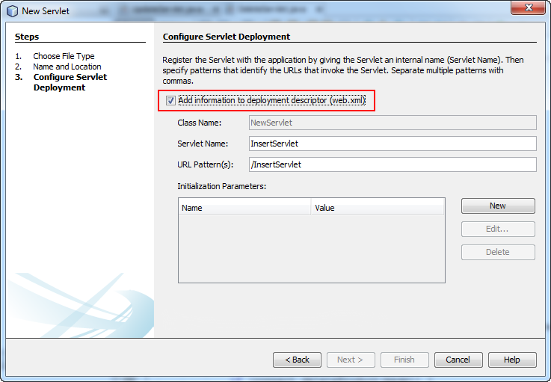](https://2.bp.blogspot.com/-ym7W5nhi7fg/V7ft7-eFnVI/AAAAAAAABqI/SbeWnPo_NIAyOo7XK2wZKVnVeKxowVlTQCLcB/s1600/2016-08-20_123742.png)

**Page Servlet InsertServlet.java**

**Java 2016**

package com.examp.giaima;

import java.io.IOException;

import java.io.PrintWriter;

import javax.servlet.ServletException;

import javax.servlet.http.HttpServlet;

import javax.servlet.http.HttpServletRequest;

import javax.servlet.http.HttpServletResponse;

/**

*

* @author Lonely

*/

public class InsertServlet extends HttpServlet {

@Override

protected void doPost(HttpServletRequest request, HttpServletResponse response) throws ServletException, IOException {

String id = request.getParameter("id");

String name = request.getParameter("name");

String company = request.getParameter("company");

double price = Double.parseDouble(request.getParameter("price"));

SanPham sp = new SanPham(id, name, company, price);

SanPhamDAO spdao = new SanPhamDAO();

try {

if (**spdao**.insertNew(sp)) {

response.sendRedirect("index.jsp");

} else {

response.sendRedirect("error.jsp");

}

} catch (Exception e) {

e.printStackTrace();

}

}

}

**Page Servlet UpdateServlet.java**

**Java 2016**

package com.examp.giaima;

import java.io.IOException;

import javax.servlet.ServletException;

import javax.servlet.http.HttpServlet;

import javax.servlet.http.HttpServletRequest;

import javax.servlet.http.HttpServletResponse;

/**

*

* @author Lonely

*/

public class UpdateServlet extends HttpServlet {

@Override

protected void doPost(HttpServletRequest request, HttpServletResponse response)

throws ServletException, IOException {

String id = request.getParameter("id");

String name = request.getParameter("name");

String company = request.getParameter("company");

double price = Double.parseDouble(request.getParameter("price"));

SanPham sp = new SanPham(id, name, company, price);

SanPhamDAO spdao = new SanPhamDAO();

try {

if (**spdao**.updateOld(sp)) {

response.sendRedirect("index.jsp");

} else {

response.sendRedirect("error.jsp");

}

} catch (Exception e) {

e.printStackTrace();

}

}

}

**Page servlet DeleteServlet.java**

**Java 2016**

package com.examp.giaima;

import java.io.IOException;

import java.io.PrintWriter;

import java.sql.SQLException;

import java.util.logging.Level;

import java.util.logging.Logger;

import javax.servlet.ServletException;

import javax.servlet.http.HttpServlet;

import javax.servlet.http.HttpServletRequest;

import javax.servlet.http.HttpServletResponse;

import com.examp.giaima.SanPhamDAO;

/**

*

* @author Lonely

*/

public class DeleteServlet extends HttpServlet {

@Override

protected void doGet(HttpServletRequest request, HttpServletResponse response)

throws ServletException, IOException {

String masp = request.getParameter("id");

SanPhamDAO spdao = new SanPhamDAO();

try {

if (**spdao**.delete(masp)) {

response.sendRedirect("index.jsp");

} else {

response.sendRedirect("error.jsp");

}

} catch (Exception e) {

e.printStackTrace();

}

}

}

**VÍ DỤ 3: SEARCHING**

Using the data table from [previous post](http://javaknowledge.info/?p=478) here I am going to explain how to search user from the database.  
  
There are two view pages here, one(index.jsp) for typing the user name and other(searchview.jsp) for displaying the search results. There is also a servlet controller(Search.java) to control against search parameter.

**index.jsp**

|  |  |
| --- | --- |
| 1  2  3  4  5  6  7  8  9  10  11  12  13  14  15  16  17  18  19  20  21 | <%@page contentType="text/html" pageEncoding="UTF-8"%>  <!DOCTYPE HTML>    <html>    <head>    </head>    <body>      <br/><br/>      <form method="post" name="frm" action="Search">        <table border="0" width="300" align="center" bgcolor="#e9f">          <tr><td colspan=2 style="font-size:12pt;" align="center">          <h3>Search User</h3></td></tr>          <tr><td ><b>User Name</b></td>            <td>: <input  type="text" name="pid" id="pid">          </td></tr>          <tr><td colspan=2 align="center">          <input  type="submit" name="submit" value="Search"></td></tr>        </table>      </form>    </body>  </html> |

**searchview.jsp**

|  |  |
| --- | --- |
| 1  2  3  4  5  6  7  8  9  10  11  12  13  14  15  16  17  18  19  20  21  22  23  24  25  26  27  28  29  30  31  32  33  34  35  36  37  38  39  40  41  42  43  44  45  46  47  48  49  50  51  52  53  54  55  56  57 | <%@ page import="java.util.*" %>    <%@page contentType="text/html" pageEncoding="UTF-8"%>  <!DOCTYPE HTML>    <html>      <head>      </head>      <body>          <table width="700px" align="center"                 style="border:1px solid #000000;">              <tr>                  <td colspan=4 align="center"                      style="background-color:teal">                      <b>User Record</b></td>              </tr>              <tr style="background-color:lightgrey;">                  <td><b>User Name</b></td>                  <td><b>Password</b></td>                  <td><b>Email</b></td>                  <td><b>Registration Date</b></td>              </tr>              <%                  int count = 0;                  String color = "#F9EBB3";                  if (request.getAttribute("piList") != null) {                      ArrayList al = (ArrayList) request.getAttribute("piList");                      System.out.println(al);                      Iterator itr = al.iterator();                      while (itr.hasNext()) {                            if ((count % 2) == 0) {                              color = "#eeffee";                          }                          count++;                          ArrayList pList = (ArrayList) itr.next();              %>              <tr style="background-color:<%=color%>;">                  <td><%=pList.get(0)%></td>                  <td><%=pList.get(1)%></td>                  <td><%=pList.get(2)%></td>                  <td><%=pList.get(3)%></td>              </tr>              <%                      }                  }                  if (count == 0) {              %>              <tr>                  <td colspan=4 align="center"                      style="background-color:#eeffee"><b>No Record Found..</b></td>              </tr>              <%            }              %>          </table>      </body>  </html> |

**Search.java**

|  |  |
| --- | --- |
| 1  2  3  4  5  6  7  8  9  10  11  12  13  14  15  16  17  18  19  20  21  22  23  24  25  26  27  28  29  30  31  32  33  34  35  36  37  38  39  40  41  42  43  44  45  46  47  48  49  50  51  52  53  54  55  56  57  58  59  60  61  62  63  64  65  66  67  68  69  70  71  72  73 | import java.io.IOException;  import java.io.PrintWriter;  import java.sql.*;  import java.util.ArrayList;  import javax.servlet.RequestDispatcher;  import javax.servlet.ServletException;  import javax.servlet.http.HttpServlet;  import javax.servlet.http.HttpServletRequest;  import javax.servlet.http.HttpServletResponse;    public class Search extends HttpServlet {        protected void doPost(HttpServletRequest request, HttpServletResponse response)              throws ServletException, IOException {          response.setContentType("text/html");          PrintWriter out = response.getWriter();          Connection conn = null;          String url = "jdbc:<mysql://localhost:3306/>";          String dbName = "dbname";          String driver = "com.mysql.jdbc.Driver";          String userName = "root";          String password = "dbpass";            Statement st;          try {              Class.forName(driver).newInstance();              conn = DriverManager.getConnection(url + dbName, userName, password);              System.out.println("Connected!");              String pid = request.getParameter("pid");                ArrayList al = null;              ArrayList pid_list = new ArrayList();              String query = "select * from users where uname='" + pid + "' ";                System.out.println("query " + query);              st = conn.createStatement();              ResultSet rs = st.executeQuery(query);                while (rs.next()) {                  al = new ArrayList();    //                out.println(rs.getString(1));  //                out.println(rs.getString(2));  //                out.println(rs.getString(3));  //                out.println(rs.getString(4));                  al.add(rs.getString(1));                  al.add(rs.getString(2));                  al.add(rs.getString(3));                  al.add(rs.getString(4));                    System.out.println("al :: " + al);                  pid_list.add(al);              }                request.setAttribute("piList", pid_list);              RequestDispatcher view = request.getRequestDispatcher("/searchview.jsp");              view.forward(request, response);              conn.close();              System.out.println("Disconnected!");          } catch (Exception e) {              e.printStackTrace();          }      }        /**       * Returns a short description of the servlet.       * @return a String containing servlet description       */      @Override      public String getServletInfo() {          return "Short description";      }// </editor-fold>  } |

And this is the deployment descriptor

|  |  |
| --- | --- |
| 1  2  3  4  5  6  7  8  9  10  11  12  13  14  15  16  17  18  19 | <?xml version="1.0" encoding="UTF-8"?>  <web-app version="2.5" xmlns="<http://java.sun.com/xml/ns/javaee>" xmlns:xsi="<http://www.w3.org/2001/XMLSchema-instance>" xsi:schemaLocation="<http://java.sun.com/xml/ns/javaee> <http://java.sun.com/xml/ns/javaee/web-app_2_5.xsd>">      <servlet>          <servlet-name>Search</servlet-name>          <servlet-class>Search</servlet-class>      </servlet>      <servlet-mapping>          <servlet-name>Search</servlet-name>          <url-pattern>/Search</url-pattern>      </servlet-mapping>      <session-config>          <session-timeout>              30          </session-timeout>      </session-config>      <welcome-file-list>          <welcome-file>index.jsp</welcome-file>      </welcome-file-list>  </web-app> |